COURSE:
COMPILER CONSTRUCTION
SUBMITTED BY:
NOOR FATIMA 096
MARIAM SHOAIB 057
NOOR FATIMA 158
AYEIZA AROOB 134

ARITHMETIC EXPRESSION EVALUATOR

Compiler Construction Project Documentation;

Introduction:

An Arithmetic Expression Evaluator is a compiler component that reads mathematical expressions, checks their correctness, applies operator precedence rules, and computes the final result. The system simulates important compiler phases such as lexical analysis, syntax analysis, and evaluation.

Objectives:

• Evaluate arithmetic expressions entered by the user.
• Apply compiler construction concepts in a practical system
• Perform tokenization and parsing of expressions.
• Generate accurate results according to precedence rules.
WORK FLOW:
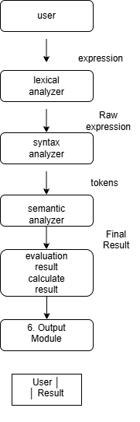

This workflow shows the flow of an expression evaluation system (like a simple compiler/interpreter).
First, the user inputs an arithmetic expression. Then the lexical analyzer converts the input into tokens (small meaningful parts like numbers and operators). After that, the syntax analyzer checks if the expression follows correct grammar rules.
Next, the semantic analyzer checks the meaning and validity of the expression. Then the system evaluates the expression and calculates the result.
Finally, the result is sent to the output module, which displays the final answer to the user

Data Flow Diagram (DFD - Level 0)

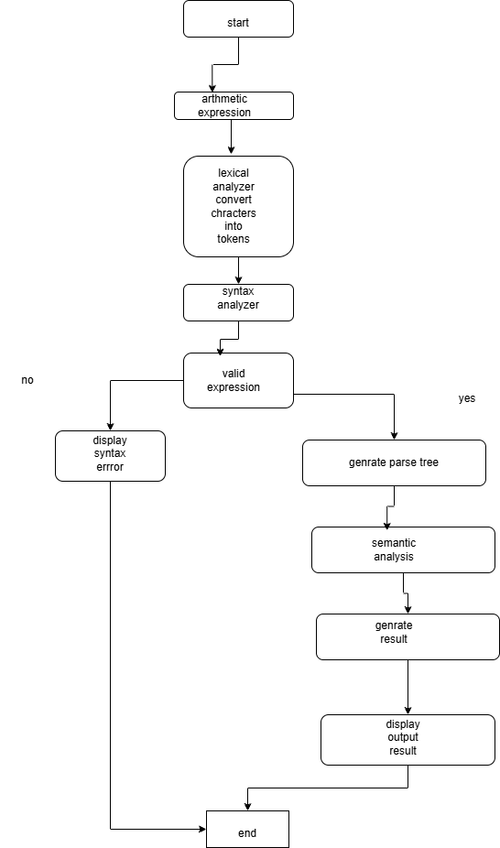

This diagram shows the working flow of an Arithmetic Expression Evaluator (like a simple compiler process).
It starts when the user gives an arithmetic expression. First, the lexical analyzer breaks the expression into small meaningful units called tokens (like numbers, operators, etc.). Then the syntax analyzer checks whether the expression follows correct grammar rules. If there is an error, it shows a syntax error message.
If the expression is valid, the system generates a parse tree, which represents the structure of the expression. After that, semantic analysis is performed to make sure the expression makes logical sense. Then the system evaluates it and generates the final result, which is finally shown to the user as output.
At the end, the process stops

FLOWCHART:
START
Read Expression
Tokenization
Syntax OK?
Evaluate
END
Di

ror
END
Yes
No

1) Input Expression: The user enters an arithmetic expression.
2) Tokenization/Parsing: The expression is broken into operands and operators.
3) Evaluation Process: The expression is evaluated based on operator precedence (+, -, *, /).
4) Output Result: The final calculated result is displayed to the user.

System Documentation
Input:
The user enters an arithmetic expression such as (5 + 3) * 2.
Lexical Analysis:
The expression is divided into tokens including numbers, operators, and parentheses.
Syntax Analysis:
The parser verifies that the expression follows valid grammar rules and contains no syntax errors.
Expression Evaluation:
The evaluator processes the expression according to operator precedence and associativity rules.
Output:
The final computed result is displayed to the user.

Example
Expression: (5 + 3) × 2
Step 1:
5 + 3 = 8
Step 2: 8 × 2 = 16 Final Result = 16

Conclusion
The Arithmetic Expression Evaluator successfully demonstrates the fundamental principles of compiler construction in a simple and practical way. It takes arithmetic expressions as input and systematically processes them through lexical analysis and syntax analysis to ensure correctness. By applying operator precedence and associativity rules, the system accurately evaluates expressions and produces reliable results. This project not only helps in understanding how compilers interpret and process mathematical expressions, but also highlights the importance of structured parsing techniques used in real-world programming languages. Overall, it provides a clear and effective implementation of how expression evaluation works inside a compiler-like system.

